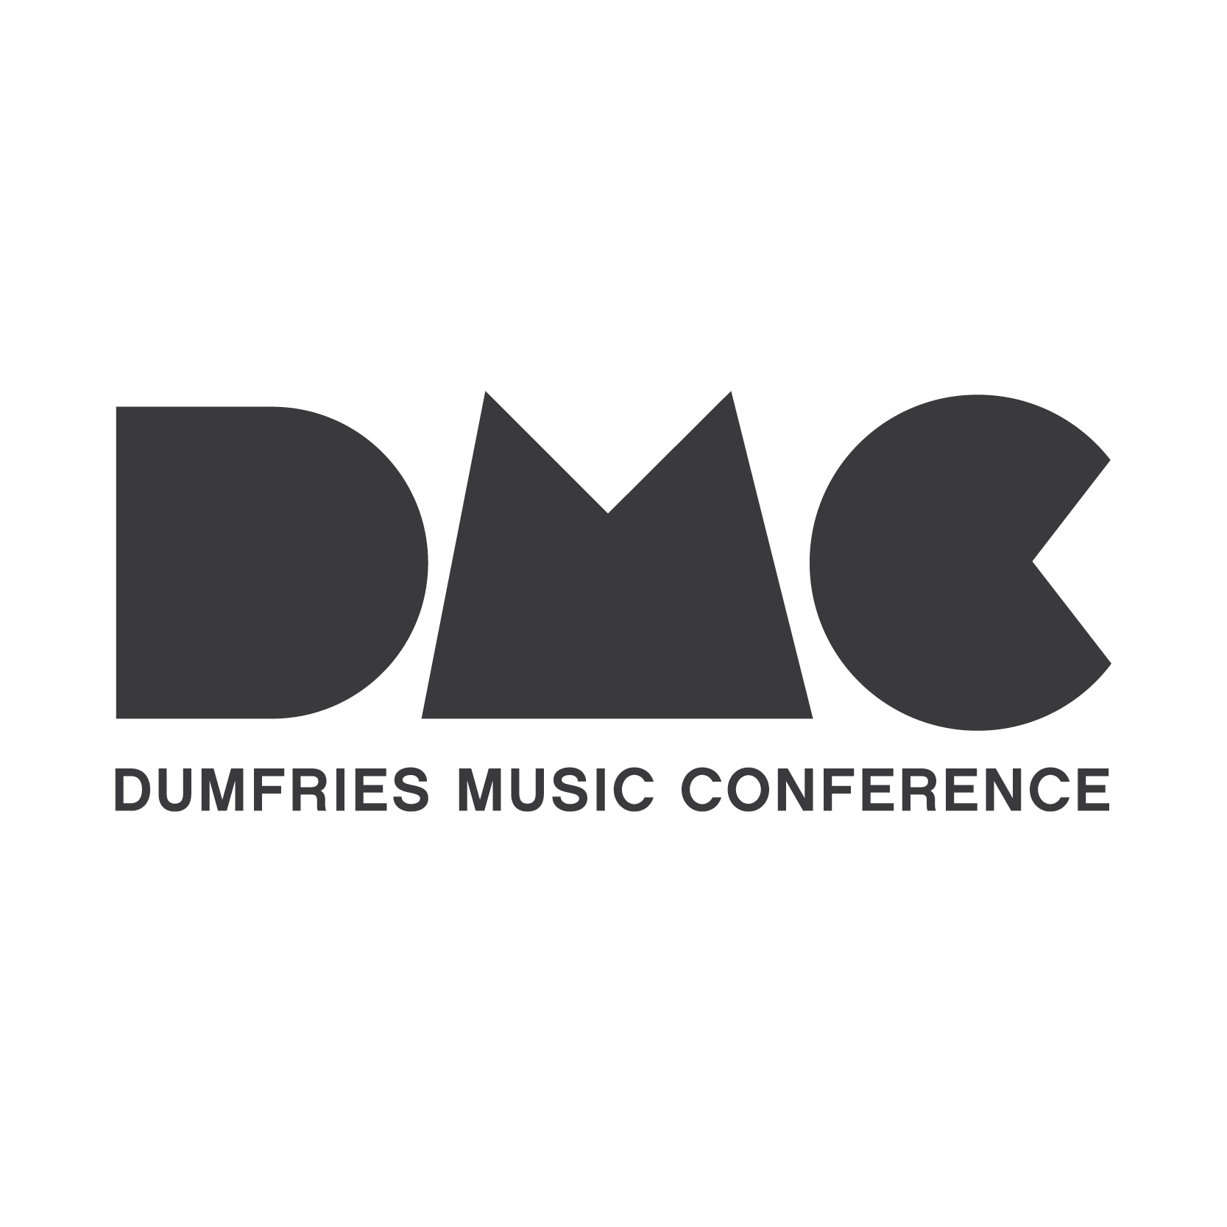

Mentoring & Professional Development Programme

Live music photography and social media

Details

This mentoring and professional development opportunity will provide applicants with the opportunity to learn key insights into live music photography and social media marketing and promotion.

The applicant will have the opportunity to work for four days (six hours per day – 24 hour in total) with a professional in this area. Areas that will be covered:

- Social Media
- Live Music Photography

The Mentee will work alongside Kirstin to create content for social media, engaging new audiences – resulting in coverage of DMC’s flagship event.

Mentor – Kirstin McEwan

Kirstin McEwan is a freelance photographer and marketing manager based in Dumfries & Galloway. Since 2016, Kirstin has been working for the Stove Network on marketing and social media as well as documentation of events and workshops.
Kirstin is the resident photographer and digital marketing manager of the Dumfries Music Conference, responsible for all social media, printed marketing and copy for DMC.
Her recent photography credits include work with the BBC, Wigtown Book Festival, Herald Scotland and Help Musicians UK. Kirstin is also founder and workshop fascilitator for the NW Photography Club in Lincluden.

Apply
To apply for the mentorship please send an up-to-date CV and Cover Letter outlining your key reasons for applying, any relevant experience and your interest in the post to dumfriesmusicconference@gmail.com

